1. Open essay (45 min max)

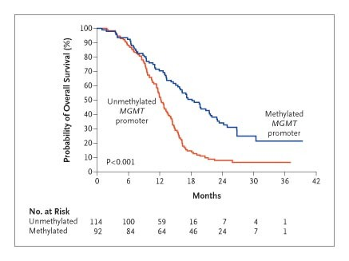

Patients treated with an anti-cancer drug X were stratified based on the methylation of the MGMT promoter in their tumors. The graph shows survival of patients with either methylated (silenced) or unmethylated (transcribed) MGMT gene in response to drug X.

Discuss the following:

A) What type of agent could drug X be? What is MGMT and what does it do?

B) Describe the clinical results. Why patients with functional MGMT do worse in response to drug X?

C) Are you familiar with other drug/target pairs that exploit a similar mechanism? Can you make one example?

2. MCQs (30 min max). Select only one answer as either true or false. One point for each correct answer (no negative points)

1. Which of the following targets can be blocked to trigger synthetic lethality in BRCA-mutant breast cancer:
- EGFR
- PI3K
- MGMT
- PARP
- β-catenin

2. Which of the following statements is false:
- Adenomas can progress to invasive adenocarcinomas
- EGFR and KRAS are frequently mutated in lung cancer
- KRAS mutations may promote resistance to EGFR inhibitors
- MGMT expression sensitizes some brain tumors to chemotherapy
- Tp53 is frequently inactivated (or mutated) in a broad spectrum of cancer types

3. Pyrimidine dimers are mutations that alter the structure of the DNA and are most often caused by:
- Alkylating agents
- UV radiation
- Carcinogens contained in cigarette tar
- Deficiency in mismatch repair enzymes
- None of the above

4. Which of these statements is true:
- All substances that cause cancer are mutagens
- Some polyps may progress to adenocarcinomas
- APC is mutated in most cancer types
- Inflammation is a tumor initiator
- KRAS is an obligatory mutation in solid cancers

5. Which of these cells/factors promote endothelial cell quiescence and stabilize blood vessels in tumors?
A. Macrophages
B. Neutrophils
C. Vascular endothelial growth factor (VEGFA)
D. Matrix metalloproteinase 9 (MMP9)
E. Angiopoietin-1 (ANG1)

6. Which of these statements about VEGFA is true:
- It mainly binds VEGFR2 on endothelial cells to promote angiogenesis
- It is strictly required for tumor angiogenesis
- Its expression is restricted to cancer cells
- Its transcription is induced by hypoxia through degradation of the HIF/pVHL complex
- It can be blocked with the monoclonal antibody vanucizumab

7. STAT3 and NFkB are transcription factors involved in tumor-associated inflammation. Which of these statements is false?
A. Inflammation may function as a tumor promoter
B. STAT3 activation in myeloid cells sustains their proliferation and maintains them in an immature state associated with tumor promotion and immunosuppression
C. NFkB activation is induced by cytokine signaling in myeloid cells and its experimental inactivation may delay tumor progression
D. Immature myeloid cells release peroxynitrite and other reactive species that can suppress T cells
E. NFkB activation suppresses myeloid cell proliferation.

8. Which of the following features of tumor blood vessels is false?
A. Their formation is, at least in part, induced by hypoxia
B. They are evenly coated by pericytes
C. They are often leaky, which limits diffusion of oxygen, nutrients and drugs to tumors
D. They recruit pericytes through PDGFB and angiopoietin signaling
E. They may regress in response to pharmacological angiopoietin-2 (ANG2) blockade

9. Which of these cytokines or receptors is best known for recruiting monocytes and promoting their maturation into macrophages?
A. Angiopoietin-1 (ANG1)
B. TIE2
C. PD-1
D. CSF1
E. EGFR

10. Which of these statements is true?
A. HPV proteins enhance pRB function, thus inducing relentless cell cycle progression and increased epithelial cell proliferation
B. Oxygen peroxide is a free radical that efficiently kills cancer cells.
C. Glutathione S transferases are upregulated in cancer cells and mediate resistance to chemotherapy
D. Regulatory T cells (T-regs) activate CD8 T cells
E. Time elapsed from exposure to carcinogens, rather than age per se, predicts cancer risk

